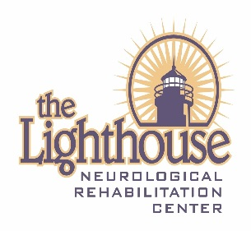

**Lighthouse Neurological Rehabilitation Center**

**2025 Adaptive Sports**

**Volunteer Information Form**

What adaptive sport clinics are you volunteering for?

Adaptive Kayak:

July 29 _____

August 19 _____

Name: __________________________________

Phone: __________________________________

Email: ___________________________________

Address: _________________________________

City: ___________________ State: _________________ Zip: ______________

Date of Birth: ____________________

Emergency Contact: ________________ Relationship: ___________________

Phone: _________________

Do you have any talents or specialties that may assist with kayaking? If so please list: ____________________________________________________________________________________________________________________________________________

Have you volunteered for the Lighthouse Adaptive Sports Events in the past?

YES _____ NO______

Signature: _________________________________________ Date: ________